DNA-V Session Discussion Tool (L. Hayes, J. Ciarrochi, D. Gillard, 2022)
This is a six-item tool that can be used for planning, assessment, and intervention. It comprises a six-item 10cm visual analogue scale (VAS) with items from the Process Based Assessment Tool (PBAT*) and DNA-v worksheet for intervention planning and session work.
You can use these tools to:
- Assess a person’s current state in each of the six DNA-v areas
- Discuss at the start of the session how they are progressing
- Use it to set an agenda for areas to work on in session
- Measure behaviour change or outcomes across sessions
- Use the disk as a way of building a visual plan for your intervention
- Use the disk is an easy take-home worksheet, session content reminder, homework etc
Note that these six items are all positive valence items. The full PBAT has items that are both positive and negative valence, and the items are independent. In other words, a client can be high on negative as well as high on positive. However, for these DNA-V tools, positive valence items were chosen for pragmatic purposes:
- It contains items that are our targets for flexible use of the DNA-v abilities
- It is brief so we don’t overwhelm the client and maximise our time
- Utility across sessions or as a repeated measure

For intervention planning and progress
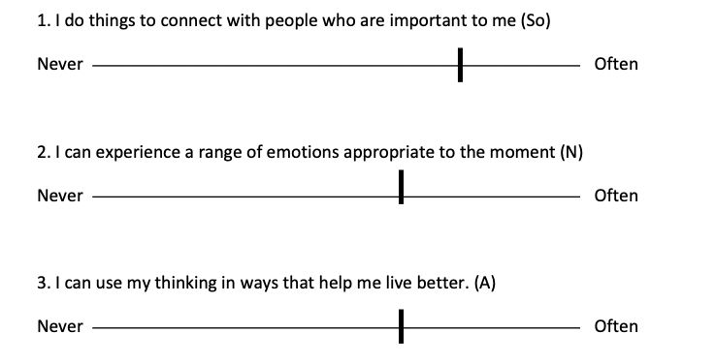
Look at the relationship between items: When using the visual analogue scale (VAS), the relationship between items is valuable because it reveals how people see their current well-being or progress. In the sample image below, item 1 is higher than the others, even if it is only marginally. Even small changes will inform your sessions:
I noticed that you marked ‘connecting with people’ as something you do more often than the other items. Would you tell me some more about that? Is it something we might consider together?
Conversely: I see that you rate yourself lower on experiencing emotions and thinking. Would you say more about that?

Consider it a measure within the individual rather than as a normative scale: An individual’s progress and change can be measured over time and interpreted idiographically. If samples A and B (below) were the same individuals across time, we could make a useful comparison about our intervention progress.
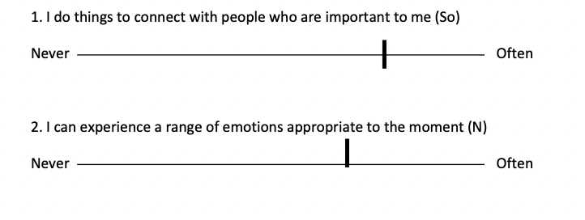
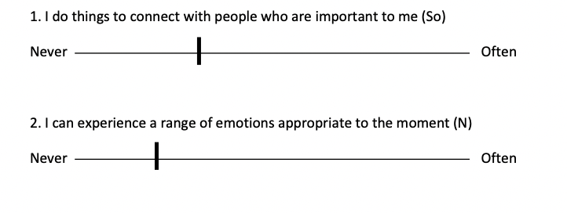
A
B

The DNA-v disk for intervention
The visual DNA-v disk with the six questions is useful for:
- Creating your intervention plan with your client
- Working with a client to help them consider how they use their abilities (D,N,A,V) and their contexts (self, social)
- Pairing it with the key DNA-v change steps that are shown throughout the book What Makes You Stronger (L. Hayes, J Ciarrohci, A. Bailey)

*Source: Adapted from the PBAT
Ciarrochi, J., Hayes, S. C., & Hofmann, S. G. (2021). Assessing Processes of Change in Psychological Interventions: The Process-Based Assessment Tool (PBAT). https://doi.org/10.31234/osf.io/2pbcf – www.pbatsupport.com

DNA-V Session Discussion Tool (L. Hayes, J. Ciarrochi, D. Gillard, 2022)
The six statements below will guide our work and make it as helpful as possible. This isn’t a measure of you but of how we can work together. It’s a way of making sure that what we do together is what you most want to work on. It's ok to say never on all questions if that’s how you feel right now. So if you’re willing, please tell me where you think you are now on these six items by putting a little mark on each line.
Name ………………………………………………………………………………………..………………………………………………….
Date ……………………………………………………………………………………………………………………………

1. I do things to connect with people who are important to me (So)
Never Often

2. I can experience a range of emotions appropriate to the moment (N)
Never Often

3. I can use my thinking in ways that help me live better. (A)
Never Often

4. I choose to do things that are personally important to me. (V)
Never Often

5. I can change my behaviour when changing helps my life. (D)
Never Often

6. I can be patient and caring towards myself (Se)
Never Often
Scale 10cm

Source: Adapted from the PBAT
Ciarrochi, J., Hayes, S. C., & Hofmann, S. G. (2021). Assessing Processes of Change in Psychological Interventions: The Process-Based Assessment Tool (PBAT). https://doi.org/10.31234/osf.io/2pbcf – www.pbatsupport.com

